Bob’s Burgers & Brews

15706 Meridian Ave E
Puyallup, WA 98375

April 19th 2023 at 7pm

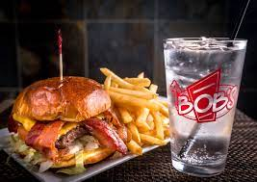

Questions:
Tony Merwin (206)455-9374
Shawn Merwin (425)208-2787

